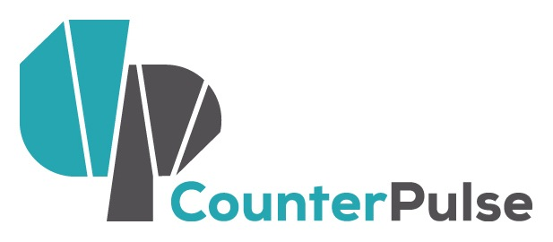 | Performance/Technology Combustible Residency  Letter of Intent: Summer 2016  Deadline: August 15, 2016  Residency Period: February - August 2017  Performance Dates: September 2017

NAME OF APPLICANT/ CONTACT PERSON:
NAME OF COMPANY (IF APPLICABLE):
ADDRESS:
CITY STATE ZIP CODE
PHONE EMAIL WEBSITE

CURATORIAL PHILOSOPHY: Combustible is part of CounterPulse’s ongoing Artist Residency program (ARC). At its core the ARC program yields to the emergent ideas from independent artists in the field. As such the curatorial directions of the program are responsive and ever changing. In tandem with this strategic impressionability, the program seeks work that is saturated with the values of relevance, transformation and innovation. Work that is nuanced and self-aware of the ways in which it is contextualized by and gives context to social, political, economic or environmental issues and phenomena are strong fits for the program.

The work of Combustible surprises audiences with how technically and aesthetically intriguing it is yet how poetically and expressively it transcends the individual mechanisms. How can current technological tools be employed to create live performance experiences that powerfully reflect today’s world? How can you work collaboratively using the full range of technology and performance potential to generate a live experience that has real impact on audiences?

Bear these provocations in mind as you compose your Letter of Intent. Additionally, please highlights ways in which your work:

- Eliminates boundaries either between disciplines, between artists and audience, between divergent communities.
- Includes collaboration between a choreographer and a lead tech creative.
- Inspires new audiences to engage with the live performance.
- Has a distinct vision for taking advantage of CounterPulse’s physical space and organizational resources at 80 Turk Street.

PROPOSAL INSTRUCTIONS:
- Complete this Letter of Intent form.
- Save your document using the following labeling system: “YourName_Combustible_ARCLOI_Fall2016.”
- Save your application either in Microsoft Word or PDF format.
- Email your application to Jodi Lomask: jodi@capacitor.org
- If you have any questions please contact jodi@capacitor.org
- Please do not submit any additional materials with your application.

DESCRIPTION OF your work and your artistic/Technical background.
Please include links to your portfolio/resume/urls (200 word max)

DESCRIPTION OF your lead collaborator’s work and his/her artistic/technical background.
Please include links to his/her portfolio/resume/urls. {if you haven’t yet located your lead collaborator, please provide a description of what you are looking for.}
(200 word max)

DESCRIPTION OF the piece you would like to develop in collaboration DURING YOUR RESIDENCY, AND WHY YOU WOULD LIKE TO DEVELOP IT AT COUNTERPULSE. (300 WORDS MAX)

WORK SAMPLE: YOU MAY SUBMIT UP TO 2 VIDEO SAMPLES of past performance work THAT TOTAL
NO MORE THAN 10 MINUTES OR SAMPLES OF CREATIVE CODING PROJECTS.
PLEASE PROVIDE CONTEXT FOR YOUR WORK SAMPLE(S). DOES THIS REPRESENT THE TYPE OF WORK
THAT YOU ARE PROPOSING? IS THIS A WORK-IN-PROGRESS OR A FINISHED PIECE? (100 WORDS MAX)

Please email this form to Jodi Lomask: jodi@capacitor.org by August 15, 2015.

