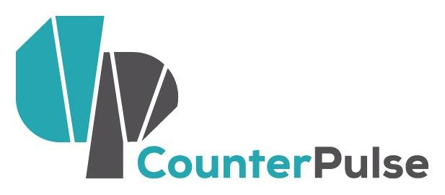 | Block Fest Artist Activators  Letter of Intent: 2016-2017  Deadline: 5PM OCTOBER 31, 2016  Activity Period: First Fridays Dec 2016 - Jun 2017

NAME OF APPLICANT/ CONTACT PERSON:
NAME OF COMPANY (IF APPLICABLE):
ADDRESS:
CITY: STATE: ZIP:
PHONE: EMAIL: WEBSITE:

Project: The Artist Activator public art opportunity is for artists working in and with the communities of the Tenderloin, or with interest in doing so. Artist Activators will partner with CounterPulse, Central City S.R.O. Collaborative (CCSROC) and Tenderloin residents to design projects to feature at a monthly Block Fest on Turk Street between Mason Street and Taylor Street. Every first Friday of the month from 3PM-4:30PM CounterPulse, CCSROC, and Artist Activators will animate the block with art, culture, and community with Block Fest. We hope to celebrate what makes the Tenderloin special, elevate underheard community concerns, and engage our neighbors in art-making and sharing.

Artists will receive a fee of $1,500, have access to up to $500 for supplies, and support from CounterPulse and CCSROC for their Block Fest projects. Projects must be able to happen outdoors near CounterPulse and CCSROC, with limited technical support.

Artists of all disciplines are encouraged to apply. Experience living and working in the Tenderloin preferred.
In addition, this opportunity is designed for artists who:

- Strive to eliminate boundaries between disciplines, artists and audience, and divergent communities.
- Include public interaction and engagement as part of their creative process
- Value the social-bond and empathy building power of arts experiences
- Have distinct experience working with the populations of the Tenderloin
- Are self-starting and able to thrive in a DIY environment
- Have vision for the arts as a tool for social justice and community action
- Have distinct ideas for making and sharing arts in CounterPulse’s 23’ x 4’ front entryway

The Letter of Intent form begins on the next page. Please complete the form and submit using the instructions below to be considered.

If you have any questions or concerns please contact rick@counterpulse.org

LETTER OF INTENT INSTRUCTIONS:
- Fill in your contact information on page 1.
- Complete this Letter of Intent form below, answering each question as completely as possible within word limits.
- Letters of Intent will be accepted via email or in hard copy.
- Please do not submit any additional materials with your application.
- To submit via email:
  - Save your document using the following labeling system: “YourName_BlockFest_LOI_2016.”
  - Save your application either in Microsoft Word or PDF format.
  - Email your application to Rick Darnell: rick@counterpulse.org
- To submit in hard copy:
  - Print your completed Letter of Intent
  - Drop-off your Letter of Intent at CounterPulse (80 Turk Street) or CCSROC (48 Turk Street).
  - Mail your Letter of Intent to:
CounterPulse
attn: Rick Darnell, Community Arts Associate
80 Turk Street
San Francisco, CA 94102

- Letters of Intent must be received (not postmarked) by 5PM MONDAY, OCTOBER 31, 2016.

DESCRIBE YOUR WORK AND YOUR ARTISTIC BACKGROUND. (200 WORD MAX)

DESCRIBE THE PROJECT YOU WOULD LIKE TO PRESENT THROUGH BLOCK FEST. (300 WORDS MAX)

WHAT ARE THE TECHNICAL NEEDS FOR YOUR PROJECT AND HOW WOULD A $500 SUPPLY BUDGET BE USED? (100 WORDS MAX)

DESCRIBE YOUR RELATIONSHIP TO THE TENDERLOIN AND HOW YOUR PROJECT SERVES OUR NEIGHBORHOOD. (300 WORDS MAX)

BLOCK FEST IS SCHEDULED FOR THE AFTERNOON OF THE FIRST FRIDAY OF THE MONTH. PLEASE INDICATE AT LEAST 2 MONTHS THAT YOU ARE AVAILABLE DECEMBER 2016-JUNE 2017. DISCUSS ANY OTHER AVAILABILITY CONCERNS WE SHOULD BE AWARE OF. (100 WORDS MAX)

WORK SAMPLE: PLEASE PROVIDE URL LINKS (PREFERRED) OF PAST OR CURRENT WORK THAT REPRESENTS YOUR PROPOSED PROJECT. YOU MAY SUBMIT:
- UP TO 10 MINUTES OF VIDEO OR AUDIO SAMPLES
- UP TO 4 PHOTOGRAPHS OF OR ARTICLES ABOUT YOUR WORK
- A COMBINATION OF 5 MINUTES VIDEO OR AUDIO AND 2 PHOTOS OR ARTICLES.

PLEASE PROVIDE CONTEXT FOR YOUR WORK SAMPLE(S). DOES THIS REPRESENT THE TYPE OF WORK THAT YOU ARE PROPOSING? IS THIS A WORK-IN-PROGRESS OR A FINISHED PIECE? (200 WORDS MAX)

Please email this form to Rick Darnell: rick@counterpulse.org or submit a hard copy to the CounterPulse (80 Turk St) or Central City S.R.O. (48 Turk St) offices by 5PM Monday, October 31, 2016.

